|  |
| --- |
| logo |
| Design Document |
| SticKart |
|  |
| **Keith Cully C00136489** |
| **16/10/12** |

# Table of Contents

Table of Contents 1

Overview of the Game 3

Description 3

Major Influences 3

Novel Aspects 4

Level Concept Visualization 4

Game Mechanics 5

Space 5

Objects 5

Actions 8

Rules 10

Skills 10

Chance 11

User Stories 12

Controller Interface 12

Menu Control System 12

Physics 13

Control Game Character 13

Level Loading 14

Choose a Level 14

Level Creation 15

Collect Power-Ups 16

Collect Bonuses 16

Take Damage from Obstacles 16

Scrolling Death 17

Activate Mine Carts 17

Transition between Carts and Platforms 18

Complete Level 18

High Score System 19

Input Name 19

Check High Scores 20

Display Level Results 20

Audio 21

Visual appeal 22

Notification System 22

Design and Create Levels 23

# Overview of the Game

## Description

SticKart is primarily a 2D side-scrolling platform game but it borrows elements from the infinite runner, puzzle and fitness genres. The game is set in a cartoon “stickman” style world with hills and platforms setting the gameplay area and layered parallax backgrounds for effect. The game will be built for the Xbox 360 and will utilize the Kinect sensor for user input.

The player controls an in game character using fully body motions. The in game character travels in a constantly moving mine cart through some of the game and runs along platforms in others. The player also controls the character’s transitions to/from the mine cart from/to a platform and from platform to platform.

There will be a loose story based on escaping the mine for some vague reason. This vagueness will be played upon to poke fun at the game itself and add some comedic value for the player.

The player’s objective is to escape the mine. They achieve this by completing all the levels of the game. To complete each level, the player must travel via cart and/or running from the start to the end of the level, all the while keeping up with the side-scrolling screen. The player will collect objects throughout the level and will be given a rating at the end of each level, based on their performance. Their score and rating will be added to a high score table.

## Major Influences

The games which SticKart takes influence from are:

1. [Rooftop Rage](http://www.youtube.com/watch?v=bYjcGJlMDCc) (WP7) – The core idea of a side scrolling game where the objective is to flee from a pursuing danger, by keeping up with the side-scrolling screen, came from this game. I have built on this by adding a far more detailed gameplay mechanic.
2. [Tiny Wings](http://www.youtube.com/watch?v=x6pT_2E5xI0) (iPhone) – The hilly, physics based level design for the mining cart is inspired by the level design of this game. SticKart builds on this by adding the player’s ability to leave the ground and utilize platform gameplay elements.
3. [Kinect Adventures](http://www.youtube.com/watch?v=UYFKSgWuS78) (Xbox360) – The fun and fitness elements are inspired by this game. The concept of using full body motion to control a simple, fun game is expanded upon to, subconsciously, encourage the player to build their fitness. The fitness aspect will not be forced upon the player but will be encouraged through placement of bonuses along running paths.
4. [Trials HD](http://www.youtube.com/watch?v=sMzXuijc79s) (Xbox360) – This game’s heavy use of physics puzzles inspired the core concept of the game. Specifically, the parts of the game where the player has to perform controlled jumps onto and off of other moving objects defined the concept for SticKart. This is built upon by the differing game mechanics and novel input methods.
5. [Sonic The Hedgehog](http://www.youtube.com/watch?v=CqOlpQ7sepE) (Sega Mega Drive) – The platform aspect of SticKart is inspired by this game. This is built upon by adding the constant threat of death if the player stops moving.

## Novel Aspects

I believe the use of full body motion to control a game of this type will make the game quite engaging and the simplicity of the game mechanic should make it quite approachable while still offering those with a desire to “be the best” an adequate challenge.

## Level Concept Visualization

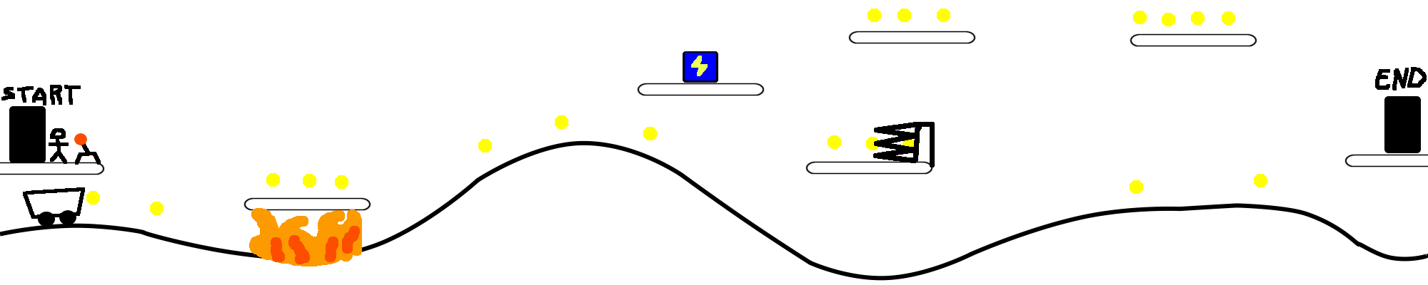

# Game Mechanics

## Space

The game is dived into individual levels which will be clearable within a few minutes each.

Each level is a 2 dimensional area, the beginning of which will be the leftmost end and the end of which will be the rightmost end. This region will also be defined by two primary sub-spaces:

1. The floor.
2. The platforms.

The floor will define the bottom boundary of each level. If the player goes below this they will die. This will consist of a hilly region, on which the mining cart travels. This region will contain hazards and gaps which the player must compensate for.

The platforms will consist of multiple platform levels which the player must run along and navigate to avoid obstacles. There will be no set upper boundary to the level. This will be defined by the height of the highest platforms and the height the player can jump from these platforms.

## Objects

Any level can contain any or all of the following;

* a stick man,
* mining carts,
* switches,
* valuable pickups,
* power-up boxes,
* obstacles,
* cameras,
* a start position and
* an end position.

### Stick Man

|  |  |  |  |  |
| --- | --- | --- | --- | --- |
| **Attribute** | **States** | **Changed By** | **Known By All** | **Player informed By** |
| Minimum horizontal speed | 0km/h. | N/A. | True | Observation of movement. |
| Maximum horizontal speed | 15km/h, 30km/h or 45km/h. | The states of the on ground attribute.  The states of the active power up attribute. | True | Observation of movement. |
| Current horizontal speed | Minimum speed to maximum speed. | Player input and in game friction. | True | Observation of movement. |
| Minimum health | 0. | N/A. | True | Heads up display. |
| Maximum health | 100. | N/A. | True | Heads up display. |
| Current health | Minimum health to maximum health. | Collisions with obstacles.  The state of the active power up attribute. | True | Heads up display. |
| Jump force | 20 or 30. | The state of active power up. | True | Observation of movement. |
| In cart | True or false. | Player input and collisions with the mining cart. | True | Observation. |
| Current action | Standing, crouching, jumping, running or falling. | Player input. Update logic may change from jumping to falling. | True | Observation of movement. Sound effects. |
| On floor | True or false. | Collision with the ground sets true.  Collision with a platform sets false.  Collision with the cart sets false. | True | Observation of the character on the cart track and subsequent slow movement. |
| Active power up | None, invincible, health, jump, speed. | Collision with a power-up box sets the value. A timer resets the value to none. | True | Heads up display, colour change in player and sound effects. |

### Mining Cart

|  |  |  |  |  |
| --- | --- | --- | --- | --- |
| **Attribute** | **States** | **Changed By** | **Known By All** | **Player informed By** |
| Minimum horizontal speed | 15km/h. | N/A. | True | Observation of movement. |
| Maximum horizontal speed | 25km/h. | N/A. | True | Observation of movement. |
| Current horizontal speed | Minimum speed to maximum speed. | Game logic, in game friction and forces due to gravity on a slope. | True | Observation of movement. |
| Is moving | True or false. | Activation of a specific switch object. | True | Observation of movement. |

### Switch

|  |  |  |  |  |
| --- | --- | --- | --- | --- |
| **Attribute** | **States** | **Changed By** | **Known By All** | **Player informed By** |
| Active | True or false. | Stick man or cart colliding with switch | True | Observation of switch. Flips from red to green. Sound effect. |

### Valuable Pickup

|  |  |  |  |  |
| --- | --- | --- | --- | --- |
| **Attribute** | **States** | **Changed By** | **Known By All** | **Player informed By** |
| Value | 10, 20, 50 or 100. | The type attribute. | True | Graphical representation. |
| Type | Silver, gold, ruby or diamond. | Set on initialization. | True | Graphical representation. |

### Power up Box

|  |  |  |  |  |
| --- | --- | --- | --- | --- |
| **Attribute** | **States** | **Changed By** | **Known By All** | **Player informed By** |
| Change rate | Every 20 frames. | N/A. | True | Observation of behaviour. |
| Time since last change | 0 to change rate. | Update logic. | False | N/A. |
| Current power | Invincible, health, jump, speed. | Randomly selected when time since last change equals change rate. | True | Graphical representation on the power up box. |
| Is active | True or false. | Player collision with box sets to false. | True | Graphical representation. Sound effect on set to false. |

### Obstacle

|  |  |  |  |  |
| --- | --- | --- | --- | --- |
| **Attribute** | **States** | **Changed By** | **Known By All** | **Player informed By** |
| Type | Rock, fire, spikes. | Set on initialization. | True | Graphical representation. |
| Damage | 20, 50 or 100. | The type attribute. | True | Observation of behaviour. |
| Is active | True or false. | Player collision with obstacle sets to false. | False | N/A. |

### Camera

|  |  |  |  |  |
| --- | --- | --- | --- | --- |
| **Attribute** | **States** | **Changed By** | **Known By All** | **Player informed By** |
| Has taken photo | True or false. | Collision with player. | True | Sound effect and on screen flash. |
| Photo | Null or created. | Has taken photo attribute. | False | N/A. |

### Start Position

|  |  |  |  |  |
| --- | --- | --- | --- | --- |
| **Attribute** | **States** | **Changed By** | **Known By All** | **Player informed By** |
| Player has left | True or false. | False once the player leaving the collision area. | True | Screen starts scrolling. |

### End Position

|  |  |  |  |  |
| --- | --- | --- | --- | --- |
| **Attribute** | **States** | **Changed By** | **Known By All** | **Player informed By** |
| Player has arrived | True or false. | True once the player enters the collision area. | True | Level completion. |

## Actions

### Jump (Up)

The player can jump up to avoid obstacles. The player can jump out of the mine cart or jump to a higher platform. This ensures the player’s survival.

The player may also jump up to access different map areas. This can lead to the player achieving bonuses.

This is achieved by the player physically jumping on the spot.

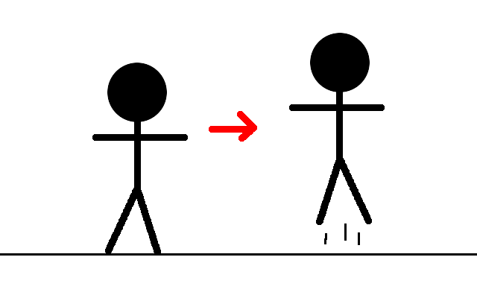

### Jump (Down)

The player can jump down to avoid obstacles. The player can jump into the mine cart from a platform or jump to a lower platform. This ensures the player’s survival.

The player may also jump down to access different map areas. This can lead to the player achieving bonuses.

This is achieved by the player physically crouching on the spot.

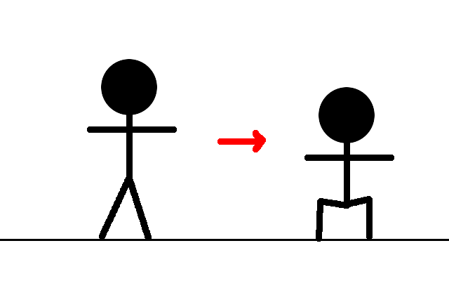

### Run

The player must run while out of the mine cart to avoid the scrolling screen from catching up with them and the subsequent death that would ensue.

This is achieved by the player physically running/jogging on the spot.

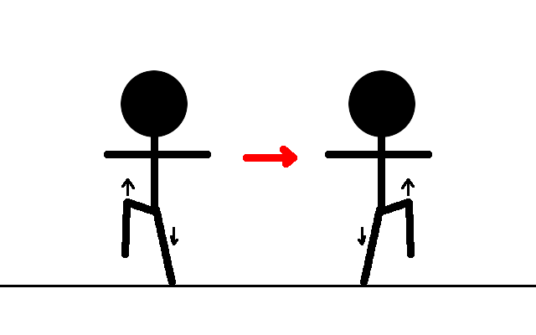

### Crouch

The player must crouch while in the mine cart to avoid obstacles. This ensures the player’s survival.

This is achieved by the player physically crouching on the spot.



### Move (In Cart)

The player can move in the mining cart to avoid the scrolling screen from catching up with them and the subsequent death that would ensue.

This is achieved by the player jumping or falling into the mining cart.

### Collect

The player may collect valuable objects or power-ups.

This is achieved by the player colliding with the collectable object, either while running or while travelling in the cart.

### Crash

The player may crash into obstacles. This causes the player’s health to decrease.

This is achieved by the player colliding with the obstacle, either while running or while travelling in the cart.

### Die

The player may die. This results in failure of the level.

This is achieved through the player crashing into too many obstacles or the scrolling screen catching up on the player.

## 

## Rules

* The player must complete all the levels to complete the game.
* The player starts at the leftmost end of a level.
* The player must reach the exit at the rightmost end of a level to complete it.
* The player may reach the exit by running and/or by traveling in a mining cart. Each possesses its own risks and rewards.
* Once the level begins, the screen scrolls at a constant rate.
* If the screen catches up with the player the player dies.
* If the player falls below the bottom boundary of the level, the player dies.
* The player starts each level with full health.
* The player loses health by crashing into obstacles.
* If the player loses all their health, they die.
* The player may collect valuables throughout the level.
* These valuables result in a score which the player gets rated on at the end of each level.
* The player may collect power-ups throughout the level.
* These power-ups have the following affects, over a short period of time: Invincible – makes the player resistant to damage. Jump – makes the player jump higher. Speed – makes the player faster. Health – gives the player health regeneration.

## Skills

### Physical Ability / Fitness

The player will require a certain level of physical ability/fitness to play the game. As the game progresses a greater physical ability will be required. There will be bonus incentives for users to take the more physically demanding routes through the level but this will not be a requirement.

### Mental Ability

The player will require mental agility and quick response times as the game world will be constantly moving once a level starts. The player will have to make quick decisions on what path to take and react appropriately. To achieve a three star rating on a level the player will have to know the level quite well, which will require a good memory or pure determination. The player will also have to apply their day to day understanding of physics to judge jumps and the movement of the mine cart.

### Real vs. Virtual Skills

Most of the skills required for the game are real as the game world is controlled by simple physics and most of the player actions are controlled by natural movements which match the game actions. Some of the mental skills are virtual skills, in that the user must learn to crouch to jump down and learn what affect a particular power-up will have.

## Chance

The player is given the opportunity to take chances by taking risky jumps. This may result in death if they do not make it and get left behind by the cart. This is encouraged by placing the biggest bonuses along risky paths.

The power-ups in the game are truly random. This will add an air of variety and uncertainty to the same section of a level.

# User Stories

## Controller Interface

As a developer, I want to implement a layer of abstraction between the game and the input device so I can easily swap the input device if necessary.

### Conditions of Satisfaction

* I can use an interface to pass standardised controls to the game. These are:
  + Select at (menu position), up, down, left, right, jump, crouch and run.
* I can use a separate interface to handle the translation of voice commands into menu or game actions if the functionality is available.
* I can accept input from the Kinect sensor.

### Storyboards

Not applicable.

## Menu Control System

As a user, I want to be able to control menus with the Kinect so my experience is positive.

### Conditions of Satisfaction

* I can see a virtual representation of my hand on screen.
* I can select any menu entry with a simple “push” hand gesture.
* I can select any menu entry using a voice command.
* I can easily determine what voice command needs to be used to select an item.

### Storyboards

## Physics

As a developer, I want to utilise a physics engine to control object movement.

### Conditions of Satisfaction

* I can create physics objects.
* I can dynamically modify the size and position of physics objects.
* I can apply forces to physics objects.
* I can update graphical representations of objects based on the state of the physics simulation.

### Storyboards

## Control Game Character

As a user, I want to be able to control the game character so I can play the game.

### Conditions of Satisfaction

* I can make the game character jump upwards by making a jump movement.
* I can make the game character jump down from a platform by making a crouch movement.
* I can make the game character crouch while in a mining cart by making a crouch movement.
* I can make the game character run while on platforms by making run movements.
* I can make the game character run while on the cart track by making run movements.

### Storyboards

## Level Loading

As a developer, I want levels to load from predefined XML files.

### Conditions of Satisfaction

* I can read in a set of points from an XML file.
* I can generate the physics objects which define the floor space from a set of points.
* I can read in a set of object definitions from an XML file.
* I can create game objects and platforms from a set of object definitions.

### Storyboards

## Choose a Level

As a user, I want to be able to select a level so I can play the game.

### Conditions of Satisfaction

* I can select a “level select” menu.
* I can see what levels are unlocked.
* I can see what levels are locked.
* I can see what levels I have already completed and my rating in each.
* I can select an unlocked level to play.

### Storyboards

## Level Creation

As a developer, I want to be able to create levels quickly and easily.

### Conditions of Satisfaction

* I can create an empty level.
* I can position all objects.
* I can position platforms.
* I can position the points which will define the floor space.
* I can save all the content created to XML files.
* I can name the XML files which I create.
* I can load a previously created level to edit it.

### Storyboards

## Collect Power-Ups

As a user, I want to collect power-ups so that the game character can have extra abilities.

### Conditions of Satisfaction

* I can pick up power ups.
* I can understand how to collect power ups.
* I can tell what power up I am about to collect.
* I can tell what power up is active.
* I can tell when the power up has expired.
* I can understand what effect power-ups cause.

### Storyboards

## Collect Bonuses

As a user, I want to collect bonuses so that the game is fun.

### Conditions of Satisfaction

* I can collect bonuses.
* I can understand how to collect bonuses.
* I can tell how much the bonus I am about to collect is worth.
* I can see how many bonus point I have collected.

### Storyboards

## Take Damage from Obstacles

As a user, I want the game to contain damaging obstacles so that the game is challenging.

### Conditions of Satisfaction

* I can see obstacles.
* I can understand how different obstacles will affect the player.
* I can avoid obstacles.

### Storyboards

## Scrolling Death

As a player, I want the game world to continuously scroll with the player dying if this scrolling catches up to them so the game is challenging.

### Conditions of Satisfaction

* I can see the level and all obstacles scrolling.
* Stickman dies if the scrolling catches up with him.
* Stickman can outrun the scrolling (slightly) if I fall behind a quarter ways across the screen.
* Stickman cannot outrun the scrolling of the screen once I get to half way across the screen, under normal circumstances.
* Stickman cannot outrun the scrolling of the screen once I three quarters of the way across the screen, when I have a speed boost upgrade.

### Storyboards

## Activate Mine Carts

As a user, I want to be able to activate mining carts so I can use them to travel.

### Conditions of Satisfaction

* I can tell how to activate a mine cart.
* I can tell when a mine cart has been activated.

### Storyboards

## Transition between Carts and Platforms

As a user, I want to be able to transition between platforms and mining carts so I can avoid obstacles and avoid death due to the side-scrolling screen catching up to the in game character.

### Conditions of Satisfaction

* I can jump onto a platform from a mining cart.
* I can fall into a mining cart.
* I can jump into a mining cart.
* I can enter a mining cart by standing in front of it and letting it catch up with me.
* I can miss be left behind by the mining cart leaving stickman moving slowly on the tracks, if I jump on the tracks behind the cart.

### Storyboards

## Complete Level

As a user, I want to be able to complete a level so I can progress through the game.

### Conditions of Satisfaction

* I can understand how to finish a level.
* I can finish a level.

### Storyboards

## High Score System

As a developer, I want to implement a high score system so the user’s scores can be tracked.

### Conditions of Satisfaction

* I can manage user data for each level which contains:
  + Level number, name, score and rating.
* I can save a list of user data entries for each level.
* I can load a list of user data for each level.

### Storyboards

Not applicable.

## Input Name

As a user, I want to be able to input my name/alias so I can be recorded in the high score table.

### Conditions of Satisfaction

* I can enter my name in the high score menu and/or upon launching the game.
* I can reuse the name I used previously without re-entering it, if I have played the game already.
* I can use arm gestures to control the letter selection.

### Storyboards

## Check High Scores

As a user, I want to check the high score table so I can see my ranking.

### Conditions of Satisfaction

* I can select a “High Score” menu.
* I can view an overall high score table.
* I can tell instantly if I am on the high score table.
* I can see where on the high score table that I am.
* I can leave the high score menu and return to the main menu.
* I can select a high score table for each level in the game.

### Storyboards

## Display Level Results

As a user, I want to see my result at the end of a level so I can judge how I did and retry the level or continue to the next level.

### Conditions of Satisfaction

* I can see my level score.
* I can see a rating for my score.
* I can tell if my score is a new high score.
* I can retry the level.
* I can continue to the next level.
* I can exit to the main menu.

### Storyboards

## Audio

As a user, I want to hear background music as I play so I can become immersed in the game.

### Conditions of Satisfaction

* I can hear music while the game is playing.
* I cannot hear music while menus are displayed.

### Storyboards

## Visual appeal

As a user, I want the game to be visually appealing so I can become immersed in the game.

### Conditions of Satisfaction

* I can tell what objects are by their graphical representation.
* I can tell what a platform is by its graphical representation.
* I can tell the screen is scrolling by the movement of the landscape.
* I can see objects scrolling at different rates to simulate depth (parallax scrolling).

### Storyboard

## Notification System

As a user, I want to see notifications so I know what’s happening.

### Conditions of Satisfaction

* I can tell what is happening throughout the game.
* I can receive heads up notifications at any time showing me how to do something or informing me of issues.

### Storyboard

## Design and Create Levels

As a user, I want the game to contain multiple levels so I can play them.

### Conditions of Satisfaction

* There are multiple levels in the game.
* The levels are fun and challenging.

### Storyboard